Water Fall Model

Waterfall approach was first a 'Process Model' to be introduced and followed widely in software engineering to ensure success of the project. In the waterfall approach, the whole process of software development is divided into separate phases. These phases in waterfall model are:
- Requirement specifications phase
- Software design
- Implementation
- Testing and maintenance
All these phases are cascaded to each other so that the second phase is started as and when a defined set of goals are achieved for first phase and it is signed off, and hence the name waterfall model. All the methods and processes undertaken in the waterfall model are more visible.

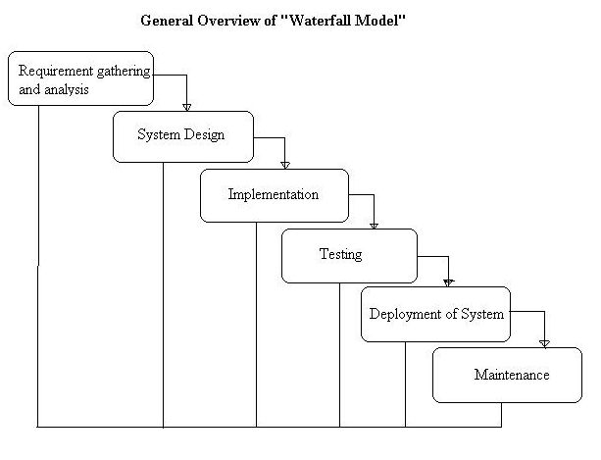

Stages of the Waterfall Model Explained
Requirement Analysis and Definition
All possible requirements of the system to be developed are captured in this phase. Requirements are a set of functions and constraints that the end user (who will be using the system) expects from the system. The requirements are gathered from the end user at the start of the software development phase. These requirements are analyzed for their validity, and the possibility of incorporating the requirements in the system to be developed is also studied. Finally, a requirement specification document is created which serves the purpose of guideline for the next phase of the model.

System and Software Design
Before starting the actual coding phase, it is highly important to understand the requirements of the end user and also have an idea of how should the end product looks like. The requirement specifications from the first phase are studied in this phase and a system design is prepared. System design helps in specifying hardware and system requirements and also helps in defining the overall system architecture. The system design specifications serve as an input for the next phase of the model.
Implementation and Unit Testing
On receiving system design documents, the work is divided in modules/units and actual coding is started. The system is first developed in small programs called units, which are integrated in the next phase. Each unit is developed and tested for its functionality; this is referred to as unit testing. Unit testing mainly verifies if the modules/units meet their specifications.
Integration and System Testing
As specified above, the system is first divided into units which are developed and tested for their functions. These units are integrated into a complete system during integration phase and tested to check if all modules/units coordinate with each other, and the system as a whole behaves as per the specifications. After successfully testing the software, it is delivered to the customer.
Operations & Maintenance
This phase of the waterfall model is virtually a never-ending phase. Generally, problems with the system developed (which are not found during the development life cycle) come up after its practical use starts, so the issues related to the system are solved after deployment of the system. Not all the problems come into picture directly but they arise from time to time and need to be solved; hence this process is referred to as maintenance.
Advantages of the Waterfall Model
- There is clear compartmentalization of work and control in the waterfall model. Since there is compartmentalization, it is easier to set schedule for the tasks to be completed within a specified time period.
- The other advantage of this model is that only after the work for a particular phase is over, does the other phase start, due to which there is no overlapping of phases or the product does not have to go through different iterative steps.
- This model is the easiest to implement in the eyes of most of the mangers, due to its linear model. Since the processes of this model are carried out in linear manner, the cost of resources is reduced to a large extent, which in turn helps in reducing the cost of the project considerably.
- Lastly, the documentation and testing happens at the end of each phase, which helps in maintaining the quality of the project.

Disadvantages of the Waterfall Model
- As it is very important to gather all possible requirements during the requirement gathering and analysis phase in order to properly design the system, not all requirements are received at once, the requirements from customer goes on getting added to the list even after the end of "requirement gathering and analysis" phase, this affects the system development process and its success in negative aspects.
- The problems with one phase are never solved completely during that phase and in fact many problems regarding a particular phase arise after the phase is signed off, this result in badly structured system as not all the problems (related to a phase) are solved during the same phase.
- The project is not partitioned in phases in a flexible way.
- As the requirements of the customer go on getting added to the list, not all the requirements are fulfilled, this results in development of almost unusable system. These requirements are then met in the newer version of the system; this increases the cost of system development.
Agile Testing Methodology
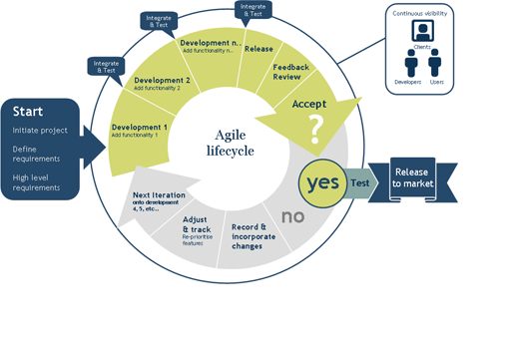

The term agile stands for 'moving quickly'. This software development methodology is based on iterative and incremental model of software development. The requirements and the solutions are a product of collaboration between self-organizing and cross functional teams. It is a lightweight software development model, which developed in the 1990s'. This model was developed against the background of the heavyweight models, which were famous for being heavily regulated, regimented, micromanaged.
There were certain principles on which the agile model was to be based. The most important of the principles is customer satisfaction by giving rapid and continuous delivery of small and useful software. The delivery of the software happens at regular intervals as opposed to after a number of months, which is the case with the waterfall model. This is the point where in the waterfall model vs agile debate the agile model scores over the waterfall model. The measure of progress used in agile modeling is the different working models delivered to the client. Since the software is developed in small batches, changes can easily be introduced into the software product. There is a lot of scope for cooperation between the business people and the developers, as the requirements keep coming from the business people at regular intervals. There is a lot of emphasis laid on technical excellence and good design of the software. The software development team has to adapt regularly to the changing circumstances.
Agile modeling is a methodology, which makes use of practice for modeling and documentation of software based systems. Traditional modeling methods in software development projects have given way to these practices which are applied in a more flexible manner. It supplements the different agile methodologies like extreme programming, agile unified process and scrum models.
Advantages of Agile Model
The most important of the advantages of agile model is the ability to respond to the changing requirements of the project. This ensures that the efforts of the development team are not wasted, which is often the case with the other methodologies. The changes are integrated immediately, which saves trouble later. There is no guesswork between the development team and the customer, as there is face to face communication and continuous inputs from the client. The documents are to the point, which no leaves no space for ambiguity. The culmination of this is that high quality software is delivered to the client in the shortest period of time and leaves the customer satisfied.
Disadvantages of Agile Model
If the projects are smaller projects, then using the agile model is certainly profitable, but if it is a large project, then it becomes difficult to judge the efforts and the time required for the project in the software development life cycle. Since the requirements are ever changing, there is hardly any emphasis, which is laid on designing and documentation. Therefore, chances of the project going off the track easily are much more. The added problem is if the customer representative is not sure, then the project going off track increase manifold. Only senior developers are in a better position to take the decisions necessary for the agile type of development, which leaves hardly any place for newbie programmers, until it is combined with the senior’s resources.

Spiral Testing Methodology

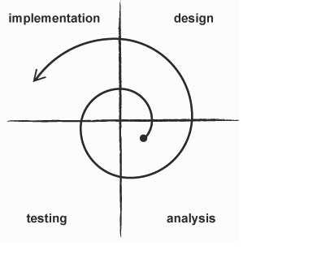
The spiral model used in software engineering combines the features of the waterfall model and the prototyping model. It is often used for large, expensive and complicated projects. This is due to the fact, the key characteristics of this model is risk management at regular stages in the entire software development cycle. Like the name suggests, the activities of software development in this model are organized like a spiral. The steps in the spiral model are generalized as follows:
- The very first step in this life cycle model is detailed system requirement definition. In this step, the requirement is perfected to the last details, by interviewing a number of users, who represent the external and/or internal users of the proposed system. The different aspects of the system are also found out in this step.
- After the system definition is made, a preliminary design is made of the proposed system. This is said to be the most important step of the spiral model. An analysis is carried out of all the possible as well as available alternatives are searched for, to develop a cost-effective system. Along with it the strategies to implement the alternatives are also decided upon.
- All the possible risks in the project are also identified in the same phase. The methods to resolve them are also determined immediately. In case of any risks, which point to uncertainty in the requirements, prototyping is used to make way with the available data and find out the solution to be able to deal with any potential changes, which may come about in the requirements.

- After the analysis, the first prototype is made using the preliminary design. It is not a full version, but a scaled down version, which represents an approximation of the final product. The characteristics of the first prototype and the final version similar to one another up to a large extent.
- The first prototype is evaluated to make the second prototype. The evaluation is made on terms of strengths, weakness and risks. Then the requirements for the second prototype are defined. Then comes the planning and designing of the second prototype, followed by constructing and testing of the second prototype.
- Accordingly the phases keep going in spirals, till the entire system is ready. The bugs from the previous prototype are fixed in the next prototype.

Advantages of Spiral Model of Software Development
The most important advantage of this model is the high amount of risk analysis, due to which the project does not face too many problems towards the end of the project. In case of any problems, the issues are addressed early in the project and the total cost of the project is also lowered. It is a good model to be used for large and mission critical projects. The software is actually made early in the life cycle.
Disadvantages of Spiral Model of Software Development
High cost involved in using this model can be called a deterrent in using this software development model. When the risk analysis is carried out, it needs highly specific expertise, which may not be forthcoming all the time. The success of the project is highly dependent on the risk analysis phase of the life cycle model. It may not prove to be useful for smaller projects.
The spiral life cycle model proves to be beneficial for projects, which are mission critical and have risky elements in it. It proves beneficial to run a series of risk reduction iterations. The other type of application, where this model is used, is for game development. It helps because the size of the project is often times large and the project has constantly shifting goals of these large projects.

V Model/ Prototype Model
V Model is called Verification and Validation Model.
V Model is a variant of the Waterfall that emphasizes the verification and validation of the product.
Testing of the product is planned in parallel with a corresponding phase of development.

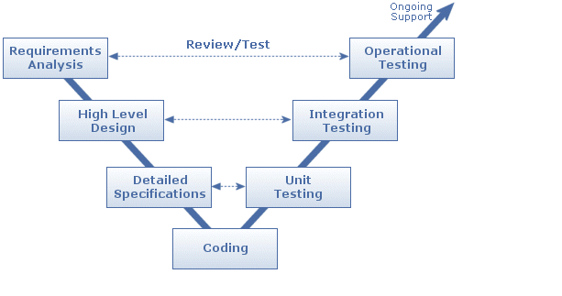
Advantages of 'V' model:
1) Simple and easy to use.
2) Testing activities like planning, test designing happens well before coding. This saves a lot of time and also helps in developing a very good understanding of the project at the beginning stage.
Disadvantages of 'V' model:
1) Very rigid and least flexible.
2) If any changes happen in mid-way, then the test documents along with requirement documents has to be updated

Software testing life cycle identifies what test activities to carry out and when (what is the best time) to accomplish those test activities. Even though testing differs between organizations, there is a testing life cycle.
Software Testing Life Cycle consists of six (generic) phases:
• Test Planning,
• Test Analysis,
• Test Design,
• Construction and verification,
• Testing Cycles,
• Final Testing and Implementation and
• Post Implementation.
Software testing has its own life cycle that intersects with every stage of the SDLC. The basic requirements in software testing life cycle is to control/deal with software testing – Manual, Automated and Performance.

Test Planning
This is the phase where Project Manager has to decide what things need to be tested, do I have the appropriate budget etc. Naturally proper planning at this stage would greatly reduce the risk of low quality software. This planning will be an ongoing process with no end point.
Activities at this stage would include preparation of high level test plan-(according to IEEE test plan template The Software Test Plan (STP) is designed to prescribe the scope, approach, resources, and schedule of all testing activities. The plan must identify the items to be tested, the features to be tested, the types of testing to be performed, the personnel responsible for testing, the resources and schedule required to complete testing, and the risks associated with the plan.). Almost all of the activities done during this stage are included in this software test plan and revolve around a test plan.

Test Analysis
Once test plan is made and decided upon, next step is to delve little more into the project and decide what types of testing should be carried out at different stages of SDLC, do we need or plan to automate, if yes then when the appropriate time to automate is, what type of specific documentation I need for testing.
Proper and regular meetings should be held between testing teams, project managers, and development teams, Business Analysts to check the progress of things which will give a fair idea of the movement of the project and ensure the completeness of the test plan created in the planning phase, which will further help in enhancing the right testing strategy created earlier. We will start creating test case formats and test cases itself. In this stage we need to develop Functional validation matrix based on Business Requirements to ensure that all system requirements are covered by one or more test cases, identify which test cases to automate, begin review of documentation, i.e. Functional Design, Business Requirements, Product Specifications, Product Externals etc. We also have to define areas for Stress and Performance testing.

Test Design
Test plans and cases which were developed in the analysis phase are revised. Functional validation matrix is also revised and finalized. In this stage risk assessment criteria is developed. If you have thought of automation then you have to select which test cases to automate and begin writing scripts for them. Test data is prepared. Standards for unit testing and pass / fail criteria are defined here. Schedule for testing is revised (if necessary) & finalized and test environment is prepared.

Construction and Verification
In this phase we have to complete all the test plans, test cases, complete the scripting of the automated test cases, Stress and Performance testing plans needs to be completed. We have to support the development team in their unit testing phase. And obviously bug reporting would be done as when the bugs are found. Integration tests are performed and errors (if any) are reported.

Testing Cycles
In this phase we have to complete testing cycles until test cases are executed without errors or a predefined condition is reached. Run test cases –> Report Bugs –> revise test cases (if needed) –> add new test cases (if needed) –> bug fixing –> retesting (test cycle 2, test cycle 3….).

Final Testing and Implementation
In this we have to execute remaining stress and performance test cases, documentation for testing is completed / updated, provide and complete different matrices for testing. Acceptance, load and recovery testing will also be conducted and the application needs to be verified under production conditions.

Post Implementation
In this phase, the testing process is evaluated and lessons learnt from that testing process are documented. Line of attack to prevent similar problems in future projects is identified. Create plans to improve the processes. The recording of new errors and enhancements is an ongoing process. Cleaning up of test environment is done and test machines are restored to base lines in this stage.

Software Testing Life cycle
Phase | Activities | Outcome
Planning | Create high level test plan | Test plan, Refined Specification
Analysis | Create detailed test plan, Functional Validation Matrix, test cases | Revised Test Plan, Functional validation matrix, test cases
Design | test cases are revised; select which test cases to automate | revised test cases, test data sets, sets, risk assessment sheet
Construction | scripting of test cases to automate, | test procedures/Scripts, Drivers, test results, Bug reports.
Testing cycles | complete testing cycles | Test results, Bug Reports
Final testing | execute remaining stress and performance tests, complete documentation | Test results and different metrics on test efforts
Post implementation | Evaluate testing processes | Plan for improvement of testing process

Bug Life Cycle:
Bug can be defined as the abnormal behavior of the software. No software exists without a bug. The elimination of bugs from the software depends upon the efficiency of testing done on the software. A bug is a specific concern about the quality of the Application under Test (AUT).
In software development process, the bug has a life cycle. The bug should go through the life cycle to be closed. A specific life cycle ensures that the process is standardized. The bug attains different states in the life cycle. The life cycle of the bug can be shown diagrammatically as follows:
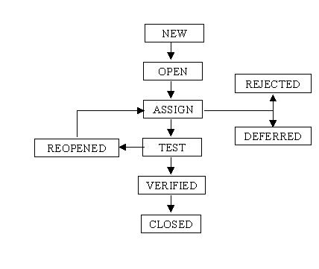
Description of Various Stages:
1. New: When the bug is posted for the first time, its state will be “NEW”. This means that the bug is not yet approved.
2. Open: After a tester has posted a bug, the lead of the tester approves that the bug is genuine and he changes the state as “OPEN”.
3. Assign: Once the lead changes the state as “OPEN”, he assigns the bug to corresponding developer or developer team. The state of the bug now is changed to “ASSIGN”.
4. Test: Once the developer fixes the bug, he has to assign the bug to the testing team for next round of testing. Before he releases the software with bug fixed, he changes the state of bug to “TEST”. It specifies that the bug has been fixed and is released to testing team.
5. Deferred: The bug, changed to deferred state means the bug is expected to be fixed in next releases. The reasons for changing the bug to this state have many factors. Some of them are priority of the bug may be low, lack of time for the release or the bug may not have major effect on the software.
6. Rejected: If the developer feels that the bug is not genuine, he rejects the bug. Then the state of the bug is changed to “REJECTED”.
7. Duplicate: If the bug is repeated twice or the two bugs mention the same concept of the bug, then one bug status is changed to “DUPLICATE”.
8. Verified: Once the bug is fixed and the status is changed to “TEST”, the tester tests the bug. If the bug is not present in the software, he approves that the bug is fixed and changes the status to “VERIFIED”.
9. Reopened: If the bug still exists even after the bug is fixed by the developer, the tester changes the status to “REOPENED”. The bug traverses the life cycle once again.
10. Closed: Once the bug is fixed, it is tested by the tester. If the tester feels that the bug no longer exists in the software, he changes the status of the bug to “CLOSED”. This state means that the bug is fixed, tested and approved.

Guidelines on deciding the Severity of Bug:
Guidelines specific to any project will specified in Test Plan, but generic are listed below
Critical / Show Stopper — An item that prevents further testing of the product or function under test can be classified as Critical Bug. No workaround is possible for such bugs. Examples of this include a missing menu option or security permission required to access a function under test.
.
Major / High — A defect that does not function as expected/designed or cause other functionality to fail to meet requirements can be classified as Major Bug. The workaround can be provided for such bugs. Examples of this include inaccurate calculations; the wrong field being updated, etc.
.
Average / Medium — The defects which do not conform to standards and conventions can be classified as Medium Bugs. Easy workarounds exists to achieve functionality objectives. Examples include matching visual and text links which lead to different end points.
.
Minor / Low — Cosmetic defects which does not affect the functionality of the system can be classified as Minor Bugs.

